221 images from excel

#Same group different concentrations (2,3,4,5 uM ACMA)

A02,A05,A07,A11

B03, B05, B09, B11

C03, C06, C08, C11

Same concentrations different group

A10,B10,C10

Average Normalized fluor for same concentration (5uM) and different groups

Positive Control= Value+-SEM (0.05325)

Negative Control=Value+-SEM(0.049876)

Experiment=Value+-SEM(0.05091)

E =value +- sem 0.047958

Nc =value +- sem 0.050838

Pc =value +- sem 0.05148

Normalization of noisy data is potentially a bad thing to do.

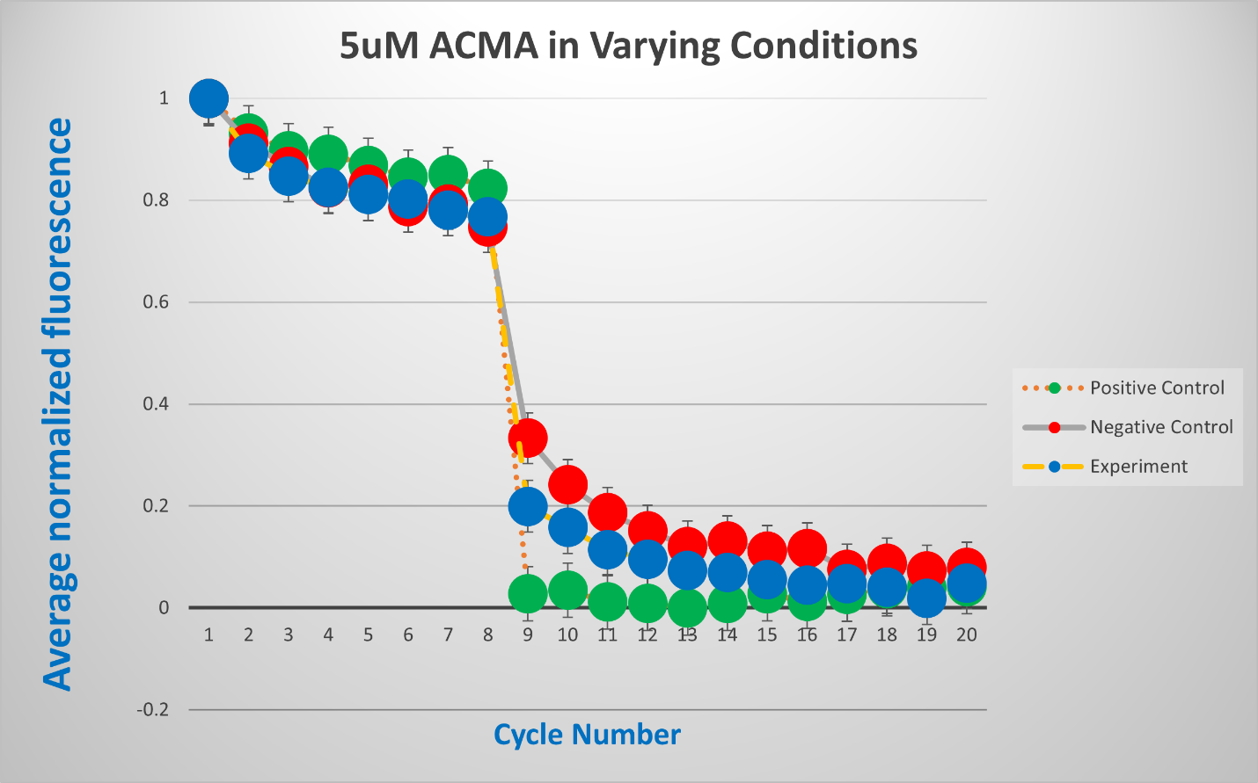

Gain of function experiments(gofs)

Loss of function experiments (lofs)

Base recording technique avoiding the recording and stimulating electrode from being together

Figure : Averaged Normalized Fluorescence (+- SEM) vs Time (s) or Cycle Number, following NavAb flux assay experiments for three groups (Experiment, Negative and positive control). N =40 based on averaged data from triplicate experiments. Image legend

Data set names code to be used in plotting in R wno error bars

Navab221

Navab227

Legend

Figure1: Averaged Normalized Fluorescence (+- SEM) vs Time (s) or Cycle Number, following NavAb flux assay experiments for three groups (Experiment, Negative and positive control). N =40 based on averaged data from triplicate experiments. Image legend represents groups correctly. ***(Source: R Studio)***